- Write a Terraform script to provision an EC2 instance.

Objective
To write and execute a Terraform configuration that provisions an AWS EC2 instance.
The goal is to understand how Terraform uses an AWS provider and an aws_instance resource to create infrastructure.
Write terraform configuration
Main.tf

terraform {
required_providers {
aws = {
source = "hashicorp/aws"
version = "~> 6.0"
}
}
}

provider "aws" {
region = "us-east-1"
}

resource "aws_instance" "my-ec2" {
ami = "ami-081b0a6eac00b4f53"
instance_type = "t3.micro"

tags = {
name = "my-terraform-instance"
}
}

Configure “ aws configure”
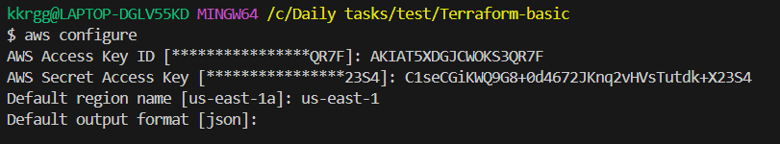

Run Terraform

Terraform init
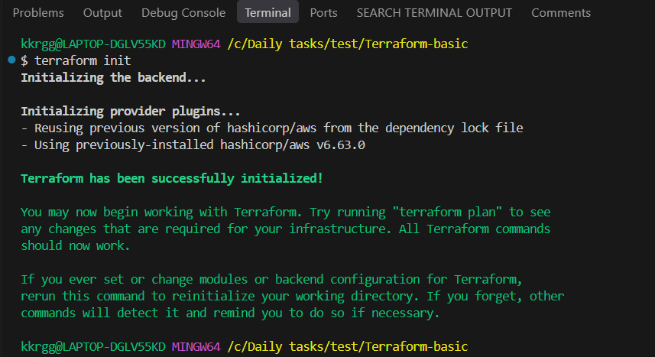

Terraform validate

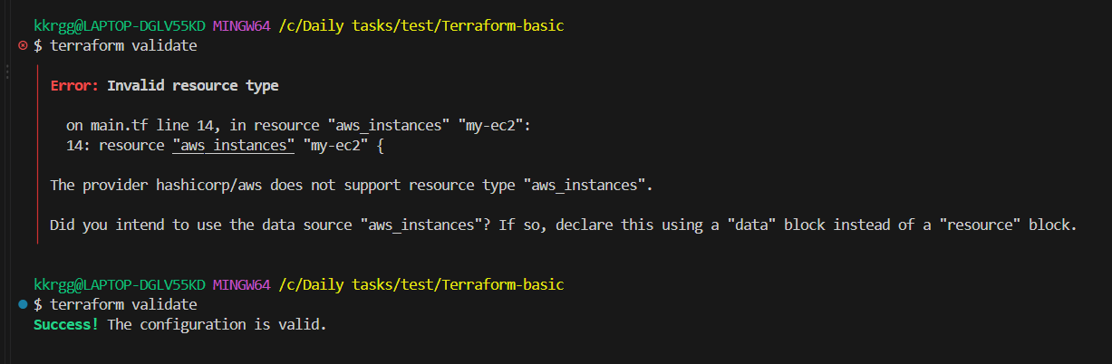

Terraform plan
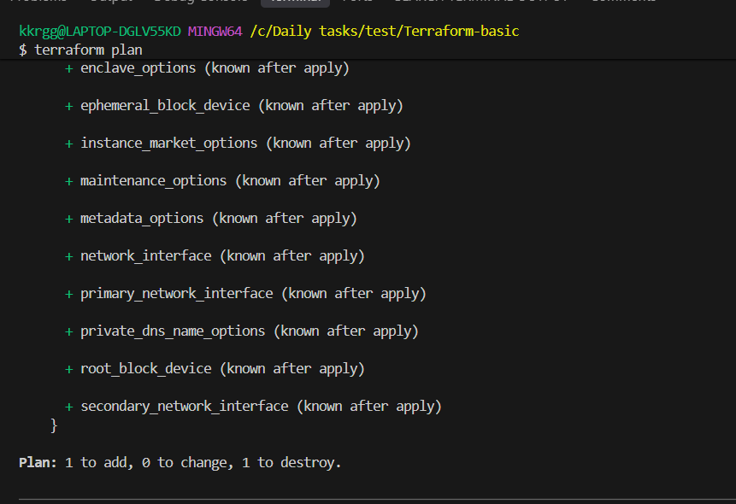

Terraform apply
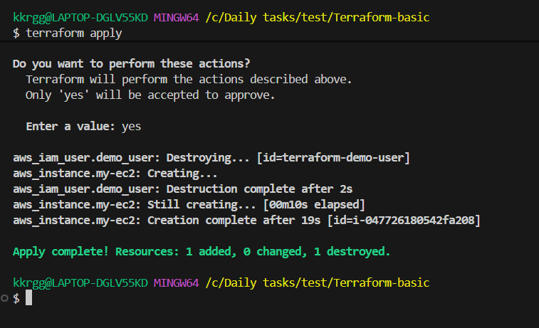

Goto AWS console

Open instances and check the created instance

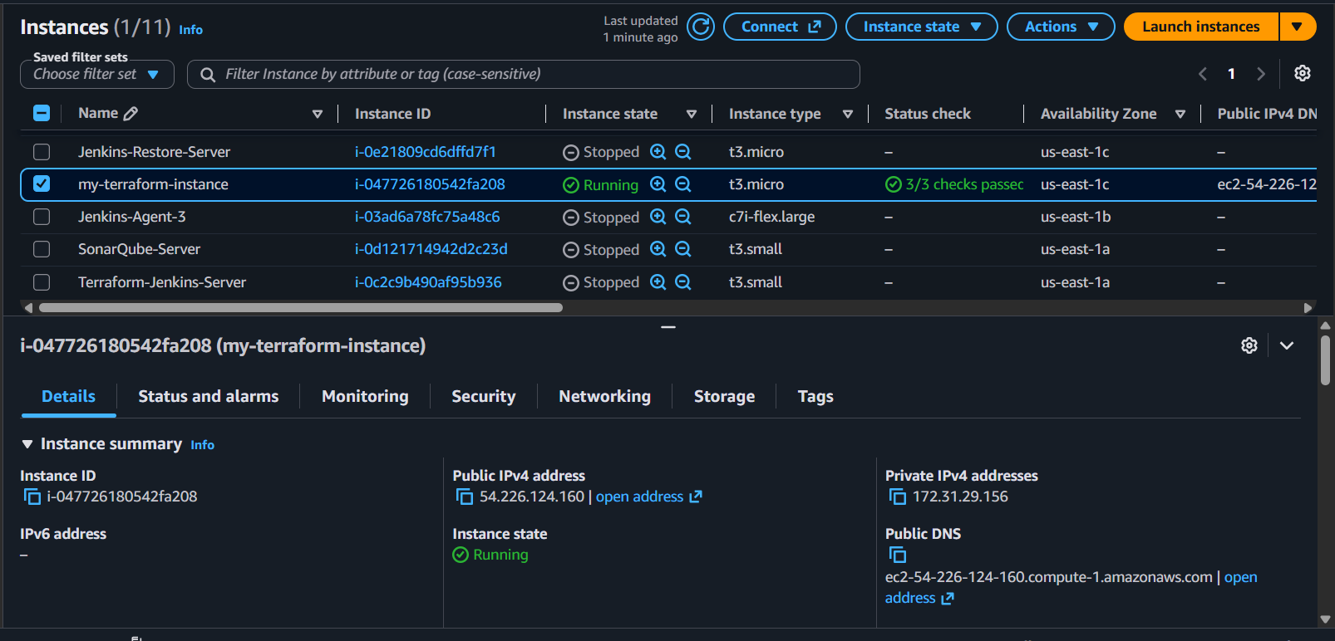

- Write a Terraform script to provision an S3 bucket.

Objective: To write and execute a Terraform configuration that provisions an AWS S3
Write terraform configuration

terraform {
required_providers {
aws = {
source = "hashicorp/aws"
}

random = {
source = "hashicorp/random"
}
}
}

provider "aws" {
region = "us-east-1"
}

resource "random_id" "bucket_suffix" {
byte_length = 4
}

resource "aws_s3_bucket" "my_bucket" {
bucket = "terraform-practice-${random_id.bucket_suffix.hex}"

tags = {
Name = "terraform-practice-bucket"
Environment = "Practice"
}
}

Why are we using random_id?
S3 bucket names must be globally unique.
Instead of manually trying names like:
terraform-practice
Terraform generates a suffix, for example:
terraform-practice-a83f21c4
So there is a much lower chance of a bucket-name conflict.

Run terraform

Terraform init
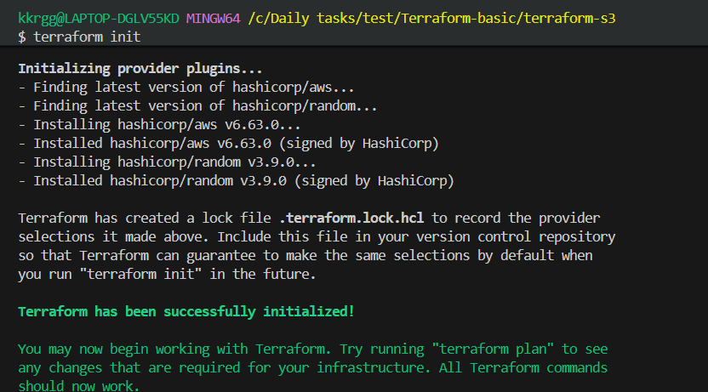

Terraform validate
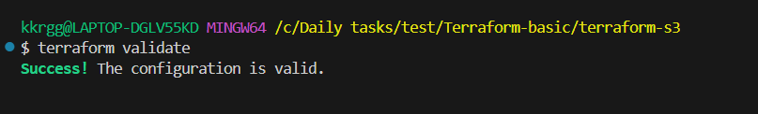

Terraform plan
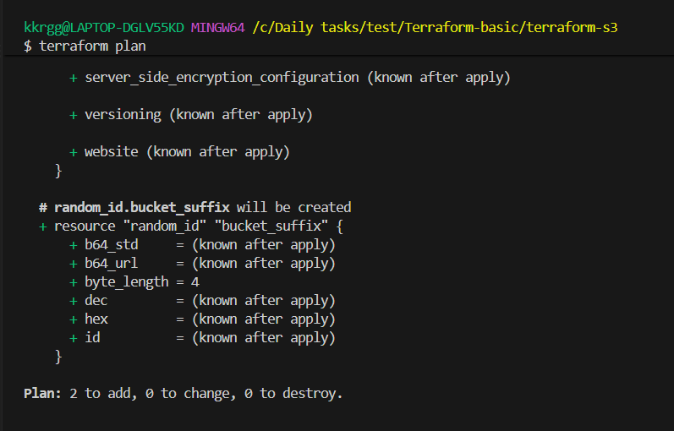

Terraform apply

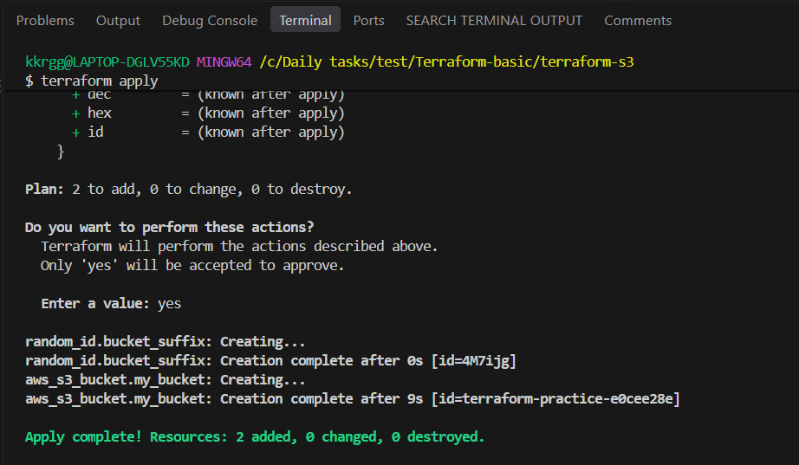

Goto AWS console

Open S3 and check the created S3 bucket

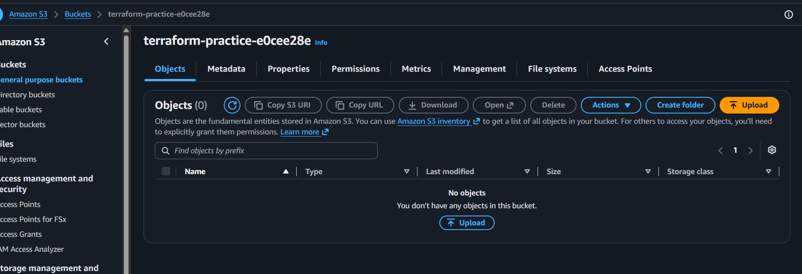

- Write a Terraform script to provision 3 EC2 instances in 3 different regions.

Objective
Create 3 EC2 instances, with one instance in each of three different AWS regions, using Terraform.
We'll use:
Instance | Region
EC2-1 | us-east-1
EC2-2 | us-west-2
EC2-3 | eu-west-1
Write terraform configuration
terraform {
required_providers {
aws = {
source = "hashicorp/aws"
}
}
}

# Region 1
provider "aws" {
alias = "us_east_1"
region = "us-east-1"
}

# Region 2
provider "aws" {
alias = "us_west_2"
region = "us-west-2"
}

# Region 3
provider "aws" {
alias = "eu_west_1"
region = "eu-west-1"
}

# EC2 in us-east-1
resource "aws_instance" "east" {
provider = aws.us_east_1

ami = "ami-0c02fb55956c7d316"
instance_type = "t3.micro"

tags = {
Name = "terraform-ec2-east"
}
}

# EC2 in us-west-2
resource "aws_instance" "west" {
provider = aws.us_west_2

ami = "ami-05f991c49d264708f"
instance_type = "t3.micro"

tags = {
Name = "terraform-ec2-west"
}
}

# EC2 in eu-west-1
resource "aws_instance" "europe" {
provider = aws.eu_west_1

ami = "ami-0d64bb532e0502c46"
instance_type = "t3.micro"

tags = {
Name = "terraform-ec2-europe"
}
}

Important concept — Provider aliases
Normally you might have:
provider "aws" {
region = "us-east-1"
}
But here we need three AWS providers:
aws.us_east_1
aws.us_west_2
aws.eu_west_1
The resource chooses which provider to use:
provider = aws.us_east_1
So Terraform knows where to create the resource.
Run terraform
Terraform init
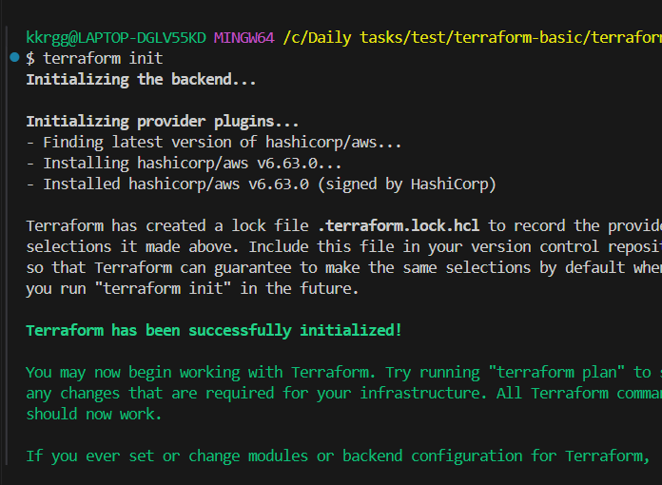
Terraform validate
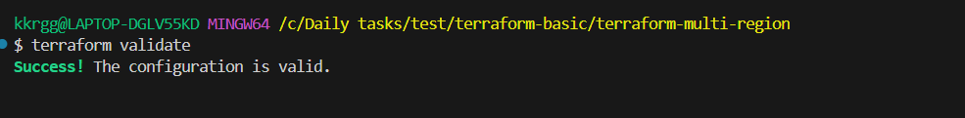
Terraform plan
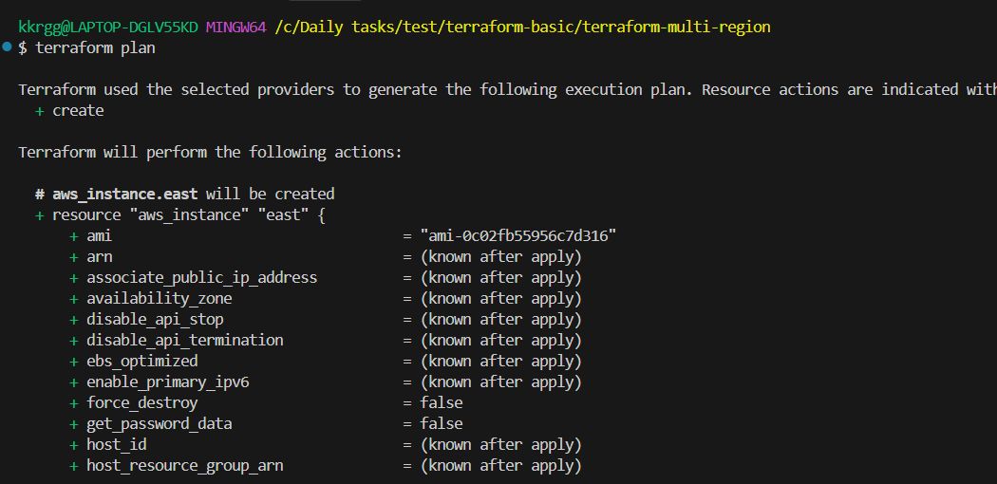
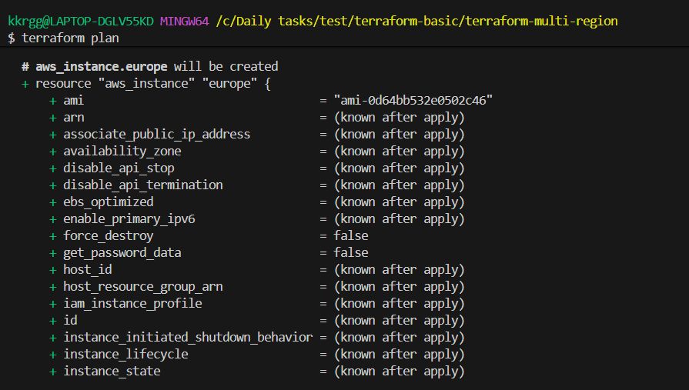
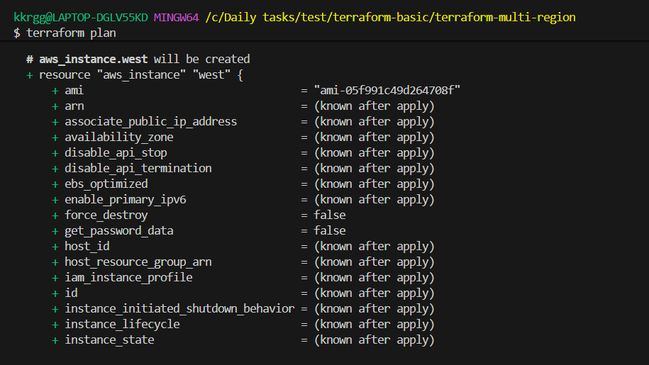
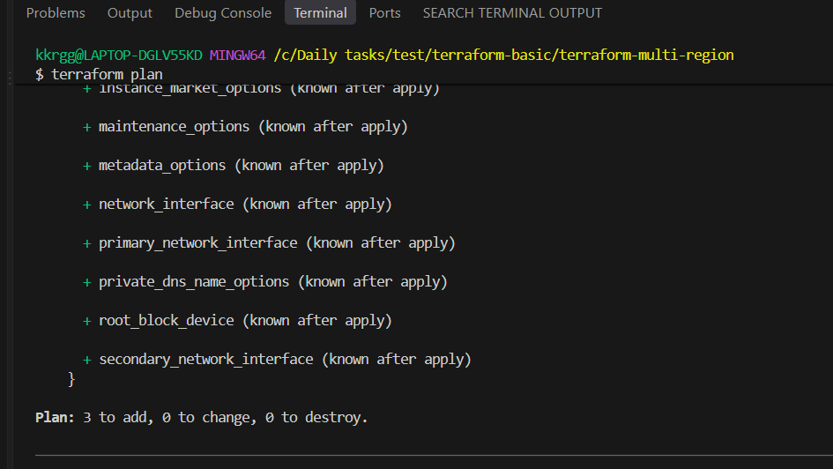

Terraform apply
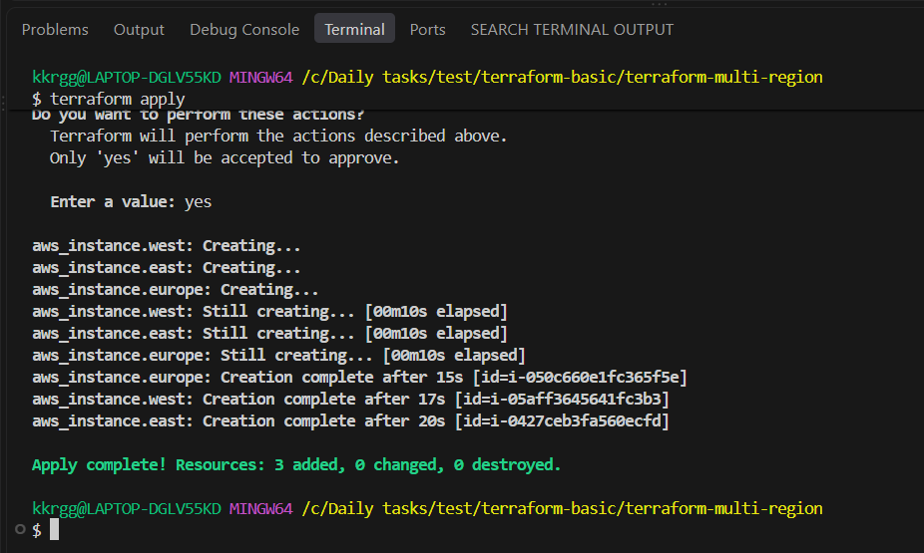
Check the AWS Console in each region.
You should have:
us-east-1
└── terraform-ec2-east

us-west-2
└── terraform-ec2-west

eu-west-1
└── terraform-ec2-europe

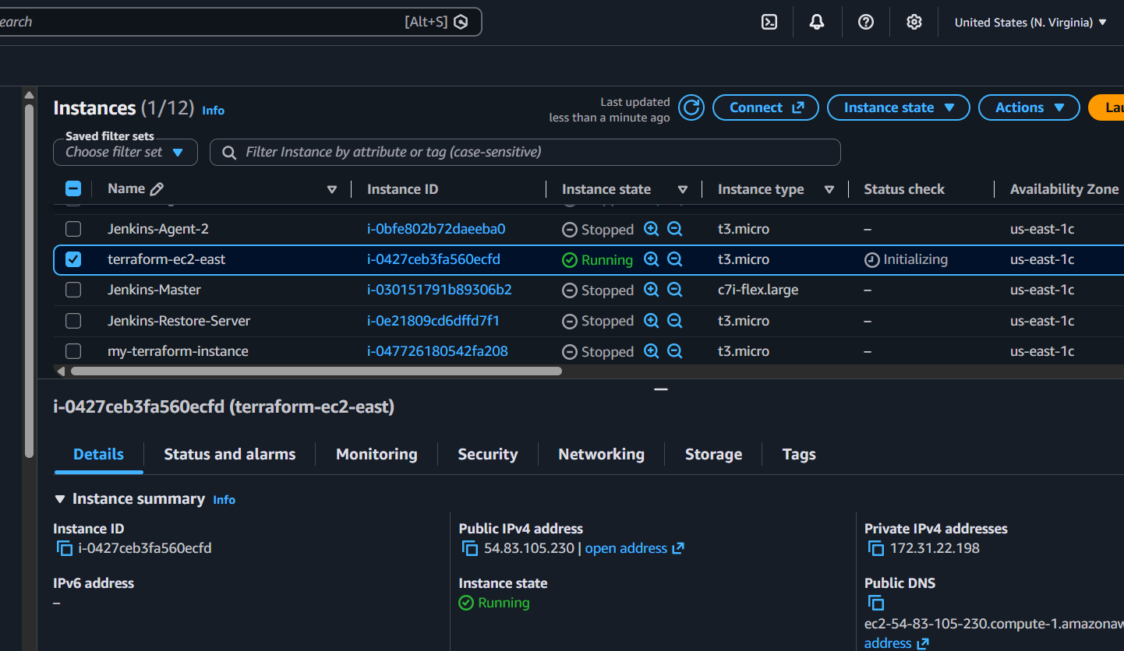
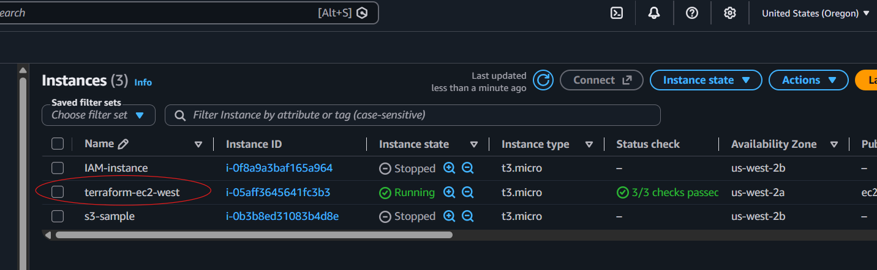
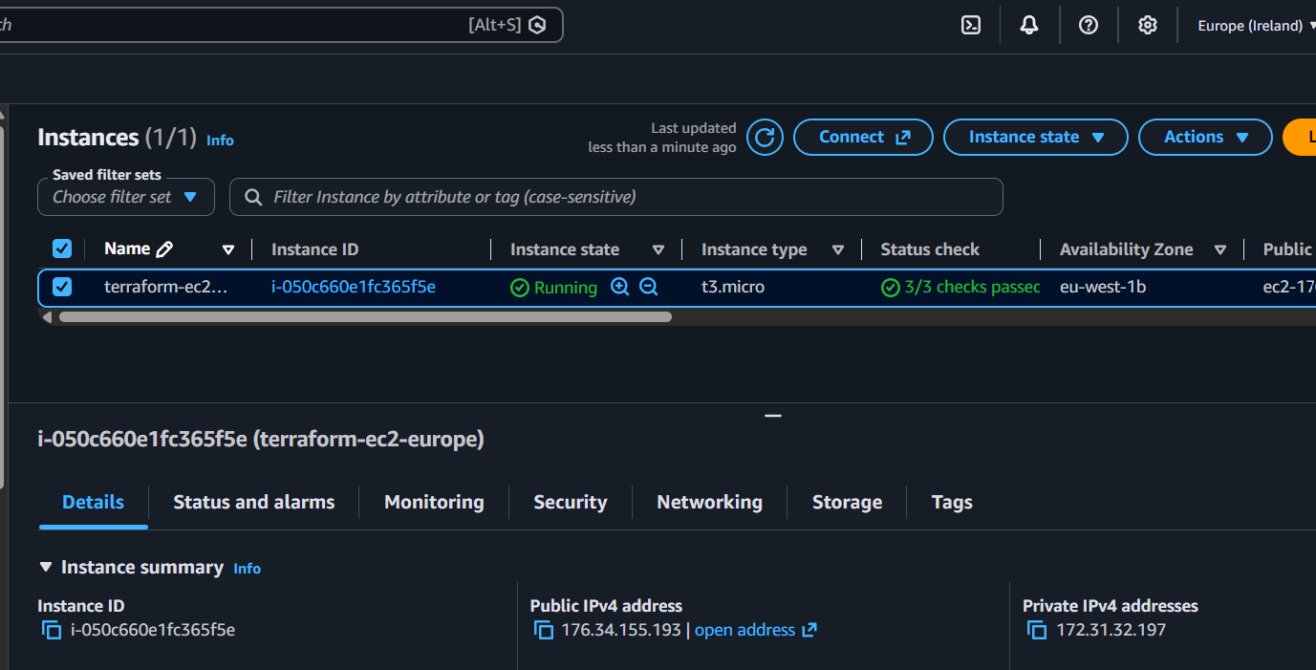

- Write a Terraform script to provision multiple EC2 instances using count and for_each.

Objective
Learn two Terraform meta-arguments for creating multiple resources:
- count
- for_each
create 3 EC2 instances using count and 3 EC2 instances using for_each.
Step 1: write terraform configuration

terraform {
required_providers {
aws = {
source = "hashicorp/aws"
}
}
}

provider "aws" {
region = "us-east-1"
}

# -------------------------
# Using count
# -------------------------

resource "aws_instance" "count_ec2" {
count = 3

ami = "ami-0c02fb55956c7d316"
instance_type = "t3.micro"

tags = {
Name = "count-ec2-${count.index + 1}"
}
}

# -------------------------
# Using for_each
# -------------------------

variable "server_names" {
default = [
"web-server",
"app-server",
"db-server"
]
}

resource "aws_instance" "foreach_ec2" {
for_each = toset(var.server_names)

ami = "ami-0c02fb55956c7d316"
instance_type = "t3.micro"

tags = {
Name = "foreach-${each.key}"
}
}

Understand count
With:
count = 3
Terraform creates:
count_ec2[0]
count_ec2[1]
count_ec2[2]
And:
count.index
gives:
0
1
2
That's why we used:
Name = "count-ec2-${count.index + 1}"
Result:
count-ec2-1
count-ec2-2
count-ec2-3

Understand for_each
With:
for_each = toset(var.server_names)
Terraform creates resources based on the actual names:
foreach- web-server
foreach- app-server
foreach- db-server

Run terraform

Terrafrom init
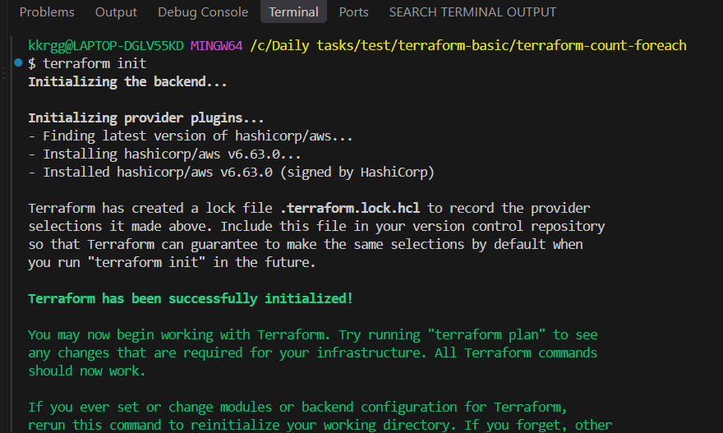

Terraform validate
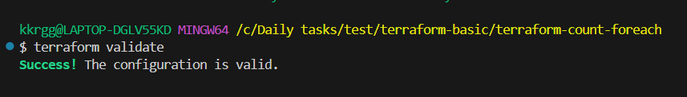

Terraform plan
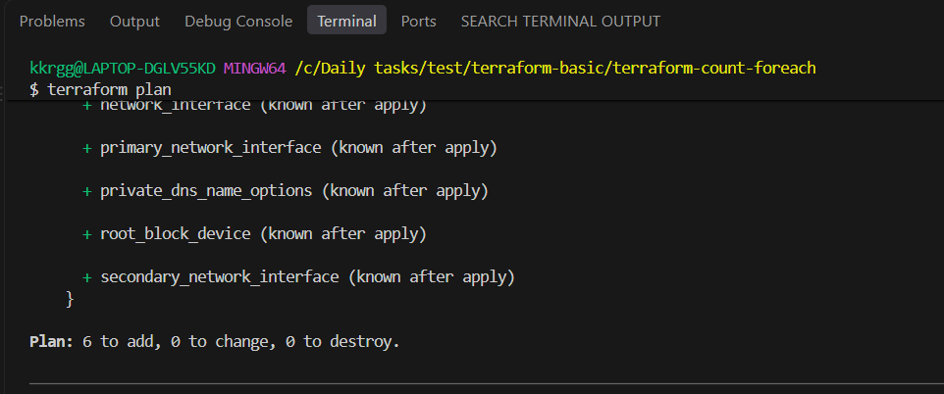

Terraform apply

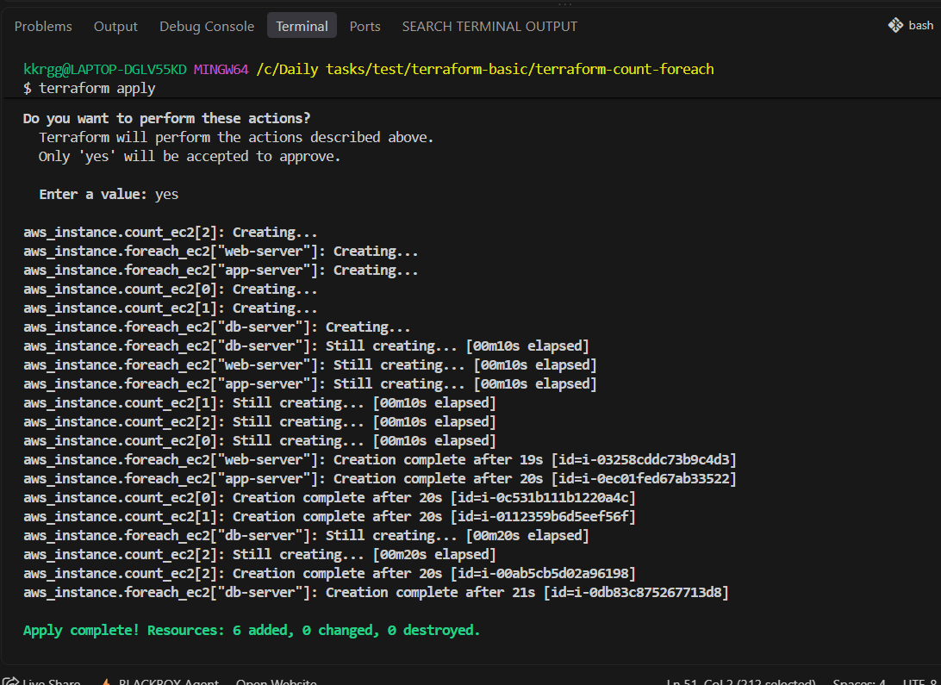

Verify
Go to:
AWS Console → EC2 → Instances → us-east-1
You should see 6 new instances:
count-ec2-1
count-ec2-2
count-ec2-3

foreach-web-server
foreach-app-server
foreach-db-server

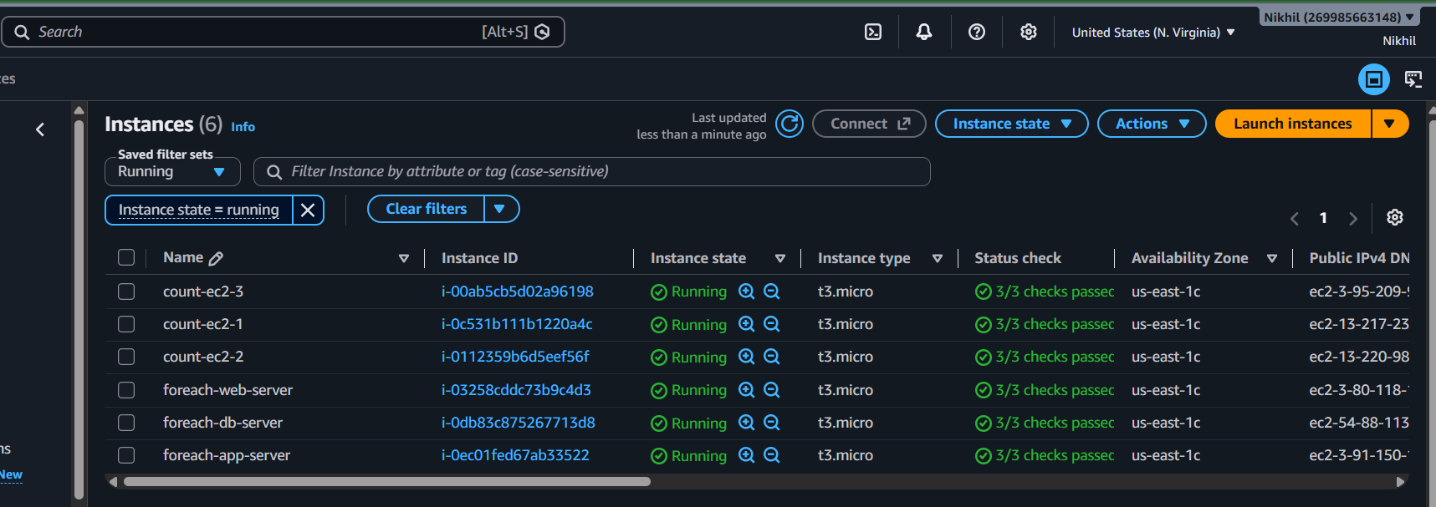

- Write a Terraform script to provision an EC2 instance using a module.
- Write a Terraform script to provision an RDS database instance.

Objective
Create an Amazon RDS MySQL database using Terraform.
We will:
- Create a MySQL RDS instance
- Use Terraform variables for the configuration
- Store the database credentials in terraform.tfvars
- Verify the RDS instance in AWS
Step 1: write terraform configuration
Main.tf
terraform {
required_providers {
aws = {
source = "hashicorp/aws"
}
}
}

provider "aws" {
region = "us-east-1"
}

resource "aws_db_instance" "mysql" {
identifier = "terraform-mysql-db"

engine = "mysql"
engine_version = "8.0"

instance_class = var.instance_class
allocated_storage = 20
storage_type = "gp3"
publicly_accessible = true
skip_final_snapshot = true
deletion_protection = false

db_name = var.db_name
username = var.db_username
password = var.db_password

tags = {
Name = "terraform-mysql-db"
Environment = "Practice"
}
}
Variables.tf
variable "instance_class" {
description = "RDS instance class"
type = string
default = "db.t3.micro"
}

variable "db_name" {
description = "Database name"
type = string
default = "mydatabase"
}

variable "db_username" {
description = "Database username"
type = string
}

variable "db_password" {
description = "Database password"
type = string
sensitive = true
}

Terraform.tfvars

db_username = "admin"
db_password = "MyPassword123!"

Run terraform

Terraform init
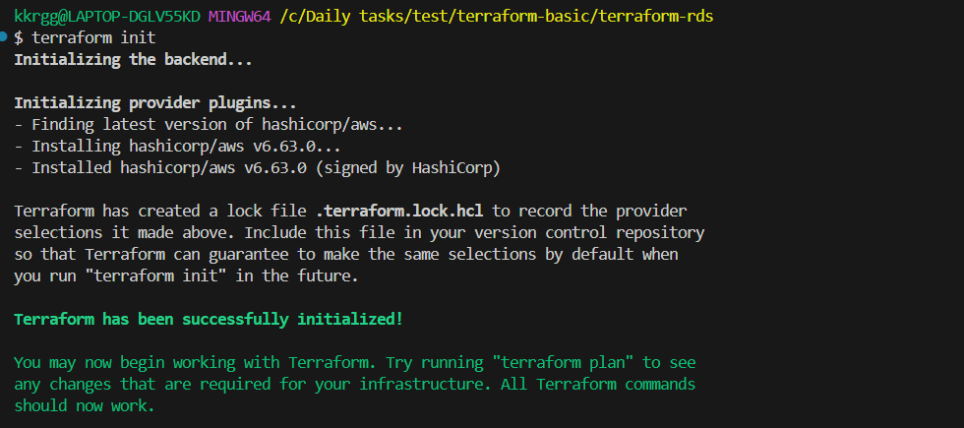

Terraform validate
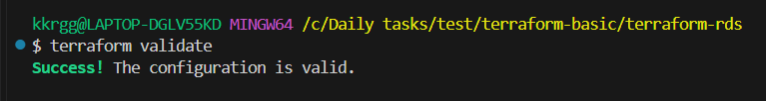

Terraform plan
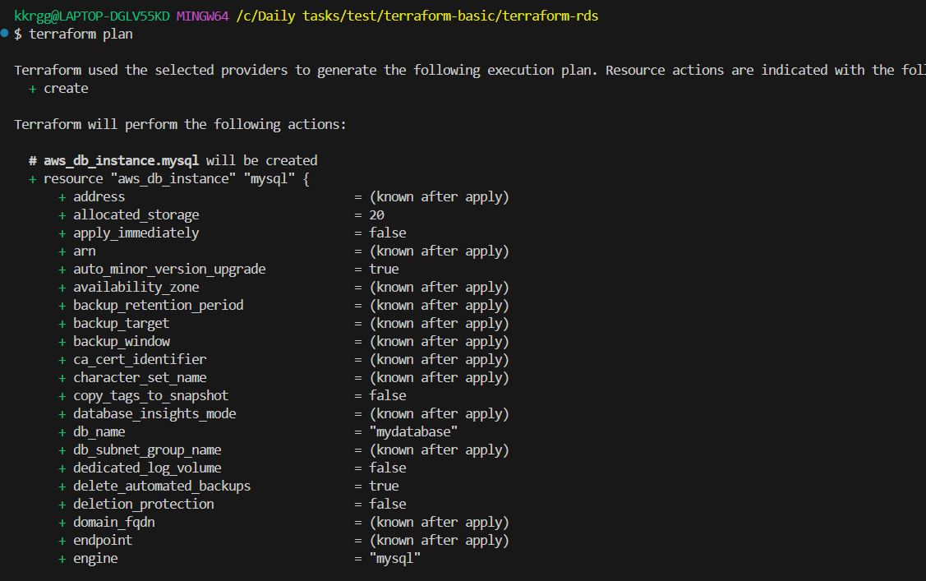

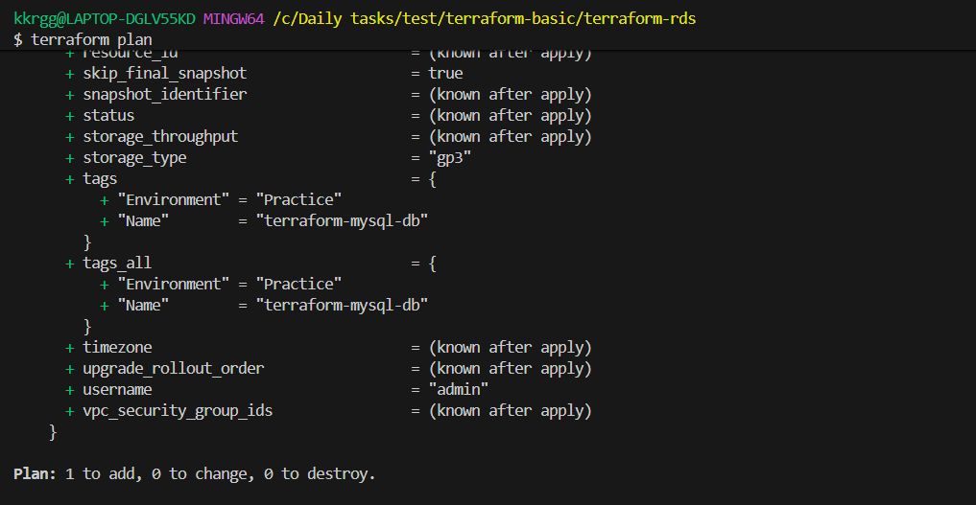

Terraform apply
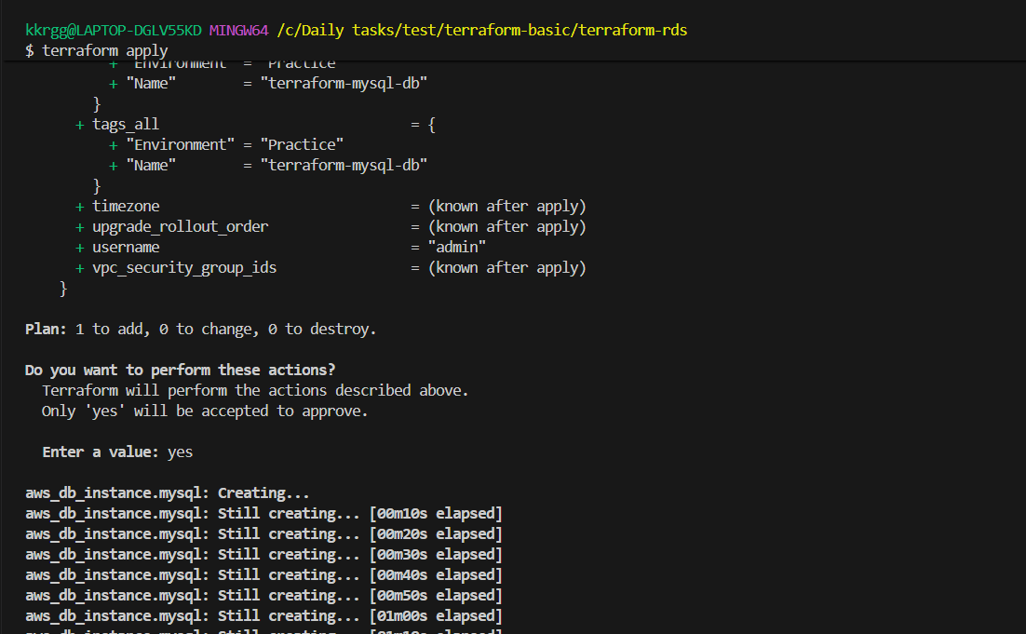

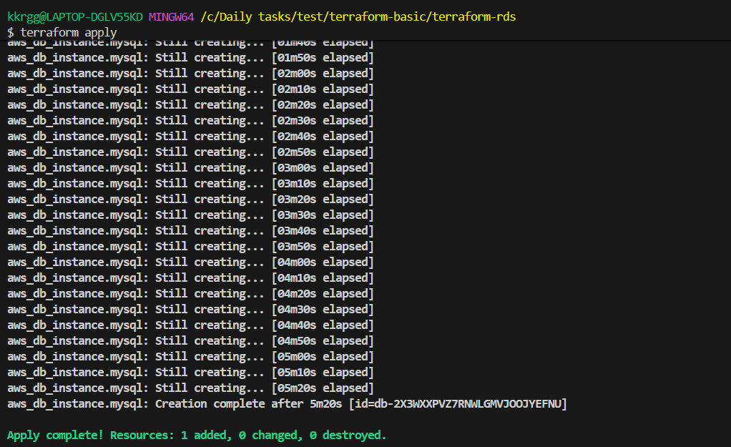

Verify in AWS RDS console

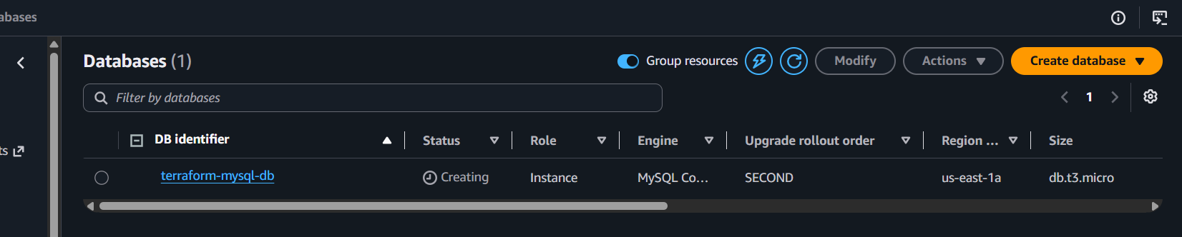

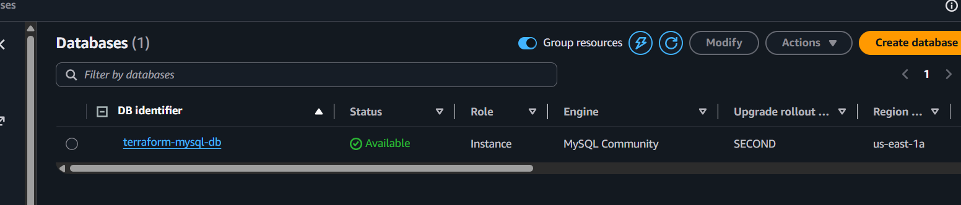

- What is the use of terraform import?
Terraform import is used to bring an existing infrastructure resource under Terraform management.
For example, suppose you manually created an EC2 instance in AWS, but it is not present in your Terraform configuration.
You can import it:
terraform import aws_instance.web i-0123456789abcdef
After import, Terraform records the resource in the state file.
However, terraform import does not automatically create the Terraform configuration code for the resource. You still need to write the corresponding resource block.
Example:
resource "aws_instance" "web" {
# configuration
}

- What is the use of terraform refresh?
terraform refresh is used to update Terraform's state file with the current state of infrastructure in the cloud.
For example:
Terraform state says:
EC2 instance type = t2.micro
But someone manually changed the instance to:
t3.micro
Terraform can refresh its state by checking the actual AWS infrastructure.

Important
In modern Terraform versions, instead of explicitly running:
terraform refresh
you normally use:
terraform plan
or:
terraform apply
These operations automatically refresh the state before determining changes.

- What is the use of Terraform workspaces?
Terraform workspaces allow you to use the same Terraform configuration for multiple environments while maintaining separate state files.
For example:
dev
qa
prod
You can create workspaces:
terraform workspace new dev
terraform workspace new qa
terraform workspace new prod
Then:
terraform workspace select dev
Terraform maintains separate state for each workspace.
Conceptually:

Terraform Configuration
|
+---- dev state
|
+---- qa state
|
+---- prod state

- What is the use of Terraform backend?
A Terraform backend defines where Terraform stores its state file and how that state is managed.
By default, Terraform uses a local state file:
terraform.tfstate
For a team, you generally don't want everyone keeping separate local state files.
You can use an S3 backend, for example:
terraform {
backend "s3" {
bucket = "my-terraform-state"
key = "prod/terraform.tfstate"
region = "us-east-1"
}
}
The state is then stored remotely.

Benefits
- Centralized state
- Team collaboration
- State locking
- Better security/access control
- State recovery/versioning when supported by the backend/storage setup
- What is the use of Terraform output block?
An output block is used to display or expose useful information from Terraform after deployment.
For example:
output "instance_ip" {
value = aws_instance.web.public_ip
}
After:
terraform apply
Terraform might show:
instance_ip = "54.123.45.67"
You can also retrieve it using:
terraform output instance_ip

Common uses
Outputs can provide:
- EC2 public IP
- Load Balancer DNS
- VPC ID
- Subnet ID
- RDS endpoint
- Resource IDs
- What is the use of Terraform data sources?
A data source is used to read existing information from infrastructure or an external source without creating that resource.
For example, suppose an AMI already exists in AWS and you want Terraform to find it.
data "aws_ami" "amazon_linux" {
most_recent = true

owners = ["amazon"]

filter {
name = "name"
values = ["al2023-ami-*"]
}
}
Then:
resource "aws_instance" "web" {
ami = data.aws_ami.amazon_linux.id
instance_type = "t3.micro"
}
Here:
data.aws_ami.amazon_linux.id
reads an existing AMI.

- What is the use of Terraform provisioners?
Provisioners allow Terraform to execute scripts or commands after or during resource creation.
For example:
resource "aws_instance" "web" {

ami = "ami-xxxx"
instance_type = "t3.micro"

provisioner "remote-exec" {
inline = [
"sudo yum update -y",
"sudo yum install nginx -y",
"sudo systemctl start nginx"
]
}
}
Common provisioners include:

local-exec
Runs a command on the machine where Terraform is executed.
provisioner "local-exec" {
command = "echo Instance created"
}

remote-exec
Runs commands on the remote resource.
provisioner "remote-exec" {
inline = [
"sudo systemctl start nginx"
]
}

file
Copies files to a remote machine.
provisioner "file" {
source = "app.conf"
destination = "/tmp/app.conf"
}

- What is Terraform statefile locking and why is it important?
State locking prevents multiple Terraform operations from modifying the same state file at the same time.
Imagine two engineers run:
terraform apply
at exactly the same time.
Without locking:
Developer A
|
+----> State file <----+
|
Developer B |
| |
+----> State file <----+
Both could modify the state simultaneously, potentially causing state corruption or conflicting changes.
With locking:
Developer A ---> 🔒 State ---> Apply
Developer B ---> WAIT
Once Developer A finishes:
State ---> 🔓
Developer B ---> Apply

Why important?
It protects against:
- Concurrent Terraform operations
- State corruption
- Conflicting updates
- Inconsistent infrastructure state

- What is the use of Terraform dynamic block?
A dynamic block is used to generate repeated nested blocks dynamically based on variables, lists, or maps.
Suppose you have multiple security-group ingress rules.
Without a dynamic block:
ingress {
from_port = 80
to_port = 80
protocol = "tcp"
cidr_blocks = ["0.0.0.0/0"]
}

ingress {
from_port = 443
to_port = 443
protocol = "tcp"
cidr_blocks = ["0.0.0.0/0"]
}
With a dynamic block:
variable "ports" {
default = [80, 443]
}
dynamic "ingress" {
for_each = var.ports

content {
from_port = ingress.value
to_port = ingress.value
protocol = "tcp"
cidr_blocks = ["0.0.0.0/0"]
}
}
Terraform generates the nested ingress blocks automatically.

- What is Terraform null_resource and when do we use it?
null_resource is a Terraform resource that doesn't represent an actual infrastructure object.
It is commonly used when you want Terraform to execute something based on resource changes.
Example:
resource "null_resource" "example" {

provisioner "local-exec" {
command = "echo Hello Terraform"
}
}
It can be used to trigger scripts or commands.
For example:
resource "null_resource" "deploy" {

triggers = {
instance_id = aws_instance.web.id
}

provisioner "local-exec" {
command = "echo Deploying application"
}
}
If the instance_id changes, the null_resource can be replaced and its provisioner can run again.

